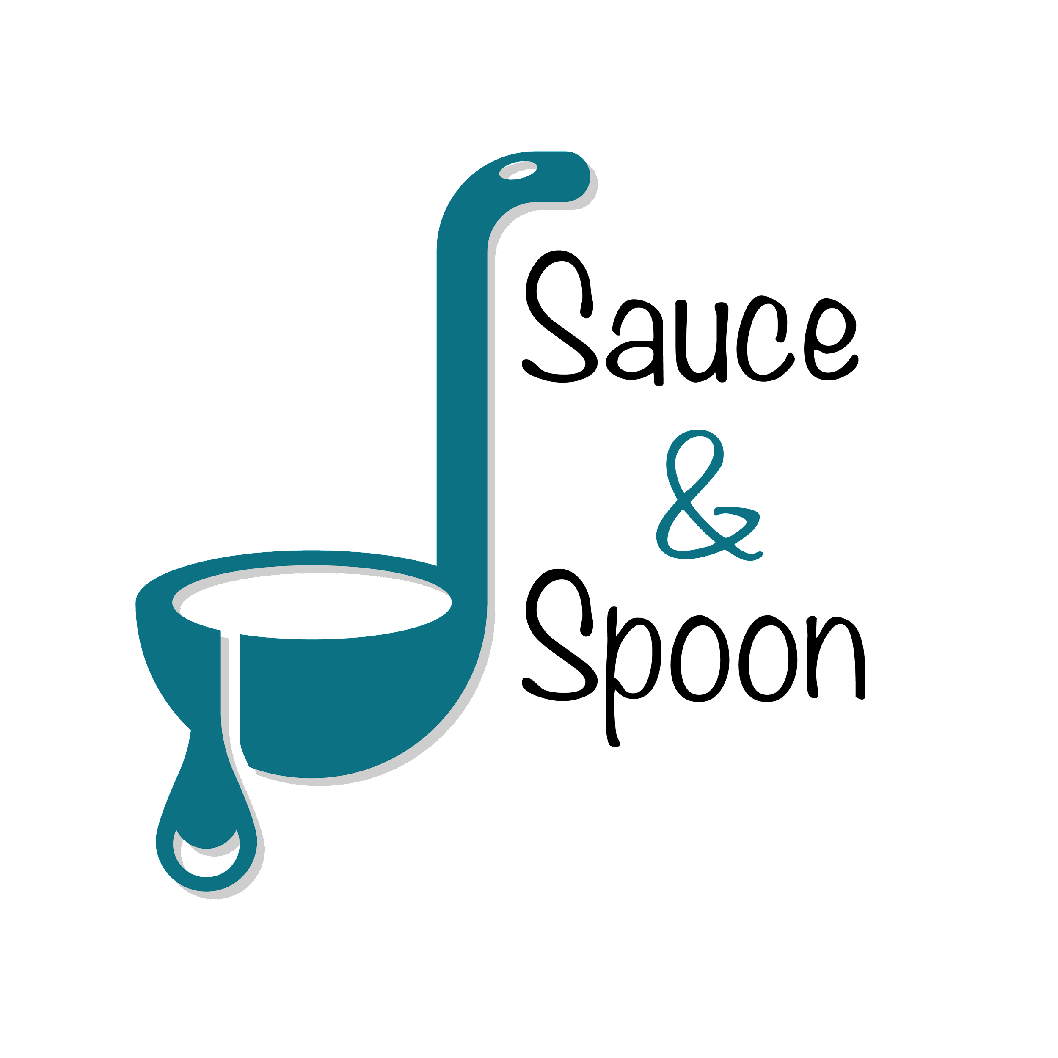

Project Charter: S&S Tabletop Menu Tablet Upgrade

DATE: 03/18/22

| **Project Summary** |
| --- |
| Offer a seamless ordering experience and improve the restaurant's ticketing system by launching a pilot rollout of tabletop menu tablets in the Bar areas at the North and Downtown locations by the beginning of Q2. This should decrease avg. table turn time, increase customer satisfaction, improves sales, and decrease food waste. |

| **Project Goals** |
| --- |
| * Improve table service productivity and efficiency by installing tabletop menu tablets in 2 locations at the start of Q2. * Increase average check total to $75 by increasing appetizer sales by 15% by the end of Q2 * Increase avg daily guest counts by 10% by decreasing average table turn time by 30 mins by the end of Q2 * Decrease avg table turn time by 30 mins through use of the new tablet system by the end of Q2 * Improve customer satisfaction by 10% through the improved speed of service and order accuracy through new tables by the end of Q2 * Cut food waste by 25% by the end of Q2. * Decrease employee burnout and turnover by 25% by potentially reallocating payroll to hire more staff. |

| **Deliverables** |
| --- |
| * Create “pilot” plan for rollout of menu tablets * Installation of tablets at “North” and “Downtown” locations * Coupon/upselling feature on tablet * Staff training guide on tablet system * Tablet integration with existing systems * Tablet package * Data points tracking system |

| **Scope and Exclusion** |
| --- |
| **In-Scope:**   * Improving Kitchen Staff satisfaction * Tablet integration rollout to 2 locations * Staff training program * Customer data points tracking system * Improving customer satisfaction * Website update * Pilot marketing * Tablet maintenance   **Out-of-Scope:**   * Food Return Policy change * Payroll reallocation * Customer loyalty program * Area layout changes * Add tablet features not relating to menu items/ticketing system |

| **Benefits & Costs** |
| --- |
| **Benefits:**   * Improve customer satisfaction through improved efficiency and accuracy * Increase in average check total * Increase in sales * Improved customer experience leading to better reviews * Decrease employee turnover rate * Decrease employee burnout * Decrease in food waste * Improve operating expenses * Improved on-boarding process for employees * Increase in daily guest count   **Costs:**   * Total Cost approx. $65k   + Training materials and fees ($10000)   + Hardware & Software implementation ($30000)   + IT Maintenance ($5000)   + Updated website and menu design ($5000)   + Other customization fees ($550)   + Overhead misc ($10000) * Tablet integration * Potential hiring of more FOH and BOH staff * Website design and impletmentation * Marketing for new pilot program |

| **Appendix:** |
| --- |
| * Deanna wants to increase avg check total from $65-75   + Can achieve this by increase appetizer sales by 15%     - North location to have a goal of 10% based on local trends suggested by Gilly     - Downtown location to have a goal of 20% based on local Trends suggested by Alex * Deanna wants to reallocate payroll FOH payroll to BOH to hire more   + Need more data from pilot to determine how much to be allocated   + Alex agrees that the kitchen will need more kitchen staff due to the higher demand put onto the kitchen   + Gilly wants to make sure to protect FOH as well, to not have to lose hosts/bartenders   + Will have to see how everything operates to determine how to allocate payroll * Deanna concerned with decreasing wait time goal   + Wait time goal could be decreased if table turn time is decreased   + Gilly suggest wait times vary based on how busy it is   + Alex in favor of dropping decrease wait time goal in favor of table turn time as it is more specific * Carter wanted a change in food return policy   + This will be a separate item discussed with Deanna |